Year 2 comprehension

.

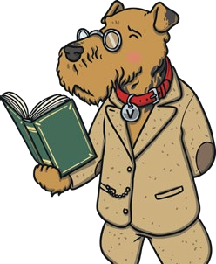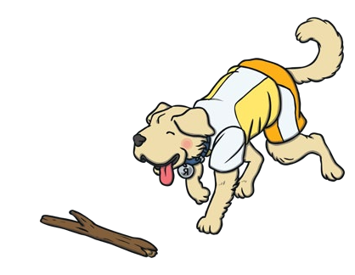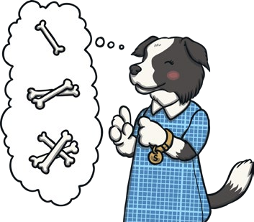

**Vocabulary Questions**

Look at how authors and poets have chosen to use certain words and phrases*.*

**Retrieval Questions**

Go into a text and retrieve the facts.

**Sequence Questions**

Sequence the events in a text.

**Prediction Questions**

Work out what might happen next.

##### Vocabulary Questions

1a: Draw on knowledge of vocabulary to understand texts.

Vocabulary is defined as the knowledge of words and word meanings. Pupils will be expected to be able to explain why an author has chosen a specific word, to discuss how the use of a certain word can create an effect and to read around an unfamiliar word to try and work out its meaning. For example, ‘Why did the author use the word ‘magnificent’ to describe the banquet?’ or ‘Find a word in the text that tells us the king is greedy.’

The best way to support the development of your child’s vocabulary is through lots of talk and lots of reading. Don’t be afraid to use more advanced vocabulary and to explain its meaning to your child. When reading to your child or hearing them read to you, discuss the meanings of words they come across and talk about how we could use those words in different situations.

##### Retrieval Questions

1b: Identify and explain key aspects of fiction and non-fiction texts, such as characters, events, titles and information.

Retrieval questions simply ask pupils to find information within the text. They test pupils’ basic understanding of what they have read and may ask about characters, the setting of the story, key events and in non-fiction texts, facts. For example,

‘Who is telling this story?’, ‘Where is the story set?’, ‘Write down one fact you

have learnt about spiders.’ When answering questions like this, it is important that

pupils are able to pick out the key bits of information rather than copying out chunks of text in the hope that the answer is in there somewhere.

The best way to support your child with retrieval is to talk about books you have shared together and ask questions about them. Encourage your child to focus on what the question is asking. For example, if you ask, ‘Who is the main character in this story?’, they shouldn’t just name all the characters but should think about who takes a main part in the story and could, therefore, be called the main character.

##### Sequence Questions

1c. Identify and explain the sequence of events in texts.

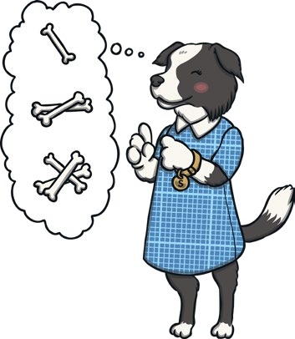Sequence questions test children’s understanding of the events that happen in a text. Typically in a SATs test, pupils will be asked to order four sentences which briefly outline the plot.

For example, ‘Number these sentences 1 to 4 in the order that they happen in the story:

The bears found Goldilocks.

The bears went for a walk in the woods. Goldilocks broke Baby Bear’s chair.

Goldilocks went into the bears’ house.

Pupils may also be asked to pick out specific events within a story, for example, ‘Who is the first character we meet in the story?’ or ‘Whose house does the witch visit first?’

To support your child’s sequencing skills, ask them to sum up the plot of a story you have just read together, thinking about what happens at the beginning, the middle and at the end. Alternatively, it can be fun to draw the story as a cartoon strip or story map, showing the order in which things happen.

##### Inference Questions

1d. Make inferences from the text.

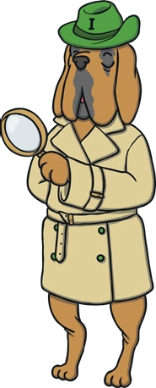Inference questions are designed to test pupils’ ability to read into the text and find the deeper meanings behind a character’s actions and words. The reader is expected to think carefully about the author’s choice of words and to be able to explain why they think these words were chosen. For example, ‘How is Sam feeling as he enters the forest? Explain your answer.’, ‘Why does the giant think he will win the fight?’, ‘Why do you think Mia ‘shivered and shook’?’

Inference questions are very much about asking pupils what they think but they must be able to justify their answer by referring back to the text. To support your child with inference questions, talk about what you have been reading together and ask lots of questions which begin with ‘why’, ‘where’, ‘who’, ‘how’, ‘what’, ‘do you think...?’ Encourage your child to explain why they think this and to go back to the story to find evidence to back up their ideas.

##### Prediction Questions

1e. Predict what might happen on the basis of what has been read so far.

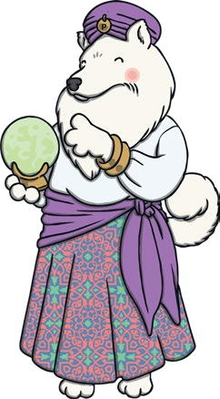As the name suggests, prediction questions ask pupils to say what they think will happen next, based on what they have read so far. For example, ‘What do you think will happen to Sam when he goes into the forest?’, ‘How do you think the story will end?’ or ‘What features would you expect to see in this type of text?’ As with inference questions, they do need to use their understanding of the text to justify their answer.

To help your child with these types of questions, stop regularly when reading together to ask, ‘What do you think will happen next?’ Discuss your child’s ideas and share your ideas too, modelling how you are thinking about what you already know about the story and the characters to help you to make predictions. Alternatively, ask your child to draw a picture to sum up the end of the story, the next page or the fate of the main character, the baddie or another character in the story.

Questions to discuss with your child when reading together

These are some examples of questions that will enable your child to use the five reading skills outlined above. You can ask these questions about texts that your child is reading either to you or independently, but it may also be worthwhile to ask questions about more challenging texts that you may be reading with your child.

##### Vocabulary Questions

Why did the author use the word ……….. to describe ?

How does this word/description make you feel about ?

Which words has the author used which make you feel ?

Can you use that word in a different sentence?

Can you find a word in the text that means the same as ?

##### Retrieval Questions

##### Where/when is this story set? Who is/are the main characters?

##### Who is the goodie/baddie? How can you tell?

How does the story end?

What is the problem that has to be solved? How is it solved?

Which is your favourite part of the story? Why?

What did you find out from reading this (non-fiction) text?

Can you think of another story that is similar to this one?

##### Sequence Questions

##### Where does the story start?

##### Who do we meet first?

##### What happens in the middle/at the end if the story?

What is the first/second/last step in these instructions?

##### Inference Questions

What do you think is thinking/feeling at this point? Why?

How do you think the author feels about ? Find words/sentences to back this up.

I wonder why ?

Can you explain why ?

Why do you think ?

How do you think ?

When do you think ?

Where do you think ?

##### Prediction Questions

What do you think will happen next?

Where do you think ….will go next

What do you think ….will say/do next?

How do you think this story will end?

Can you think of any other stories that start like this? How do they end?