Family Help East/Central Bristol Bulletin March 2026
Contents
Family Help East/Central Bristol Bulletin March 2026 1
Bristol Parenting Groups - Bristol Family Hubs 2
Children’s Scrapstore – Easter Programme 3
Creative Youth Network 4
Learning Partnership West (LPW) – Easter Play Sessions 6
Hillfields Community Centre 6
Urban Park 7
Youth Sessions (11-16) - The Swannery 8
Murmuration Community Therapy 9
Mindful Parenting & Community Project 10
NHS – Mental Health Support Team 11
Play Rangers – Children’s Scrapstore 13
Premier Holidays Club 14
Public Health Nursing – NHS 15
SAY – SEND and You 16
Appointments for Advice 16
SAY’s Topic of the Month is Tribunal 17
Super Saturday at Children’s Scrapstore 18
The Bridge Foundation 19
Therapy Support for Children and Young People 19
Therapy Group for Parents and Carers 21
Wellspring Settlement 23
Young Carers 24

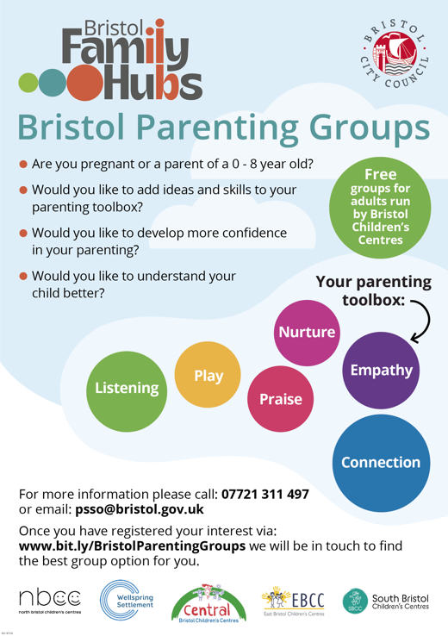

Bristol Parenting Groups - Bristol Family Hubs

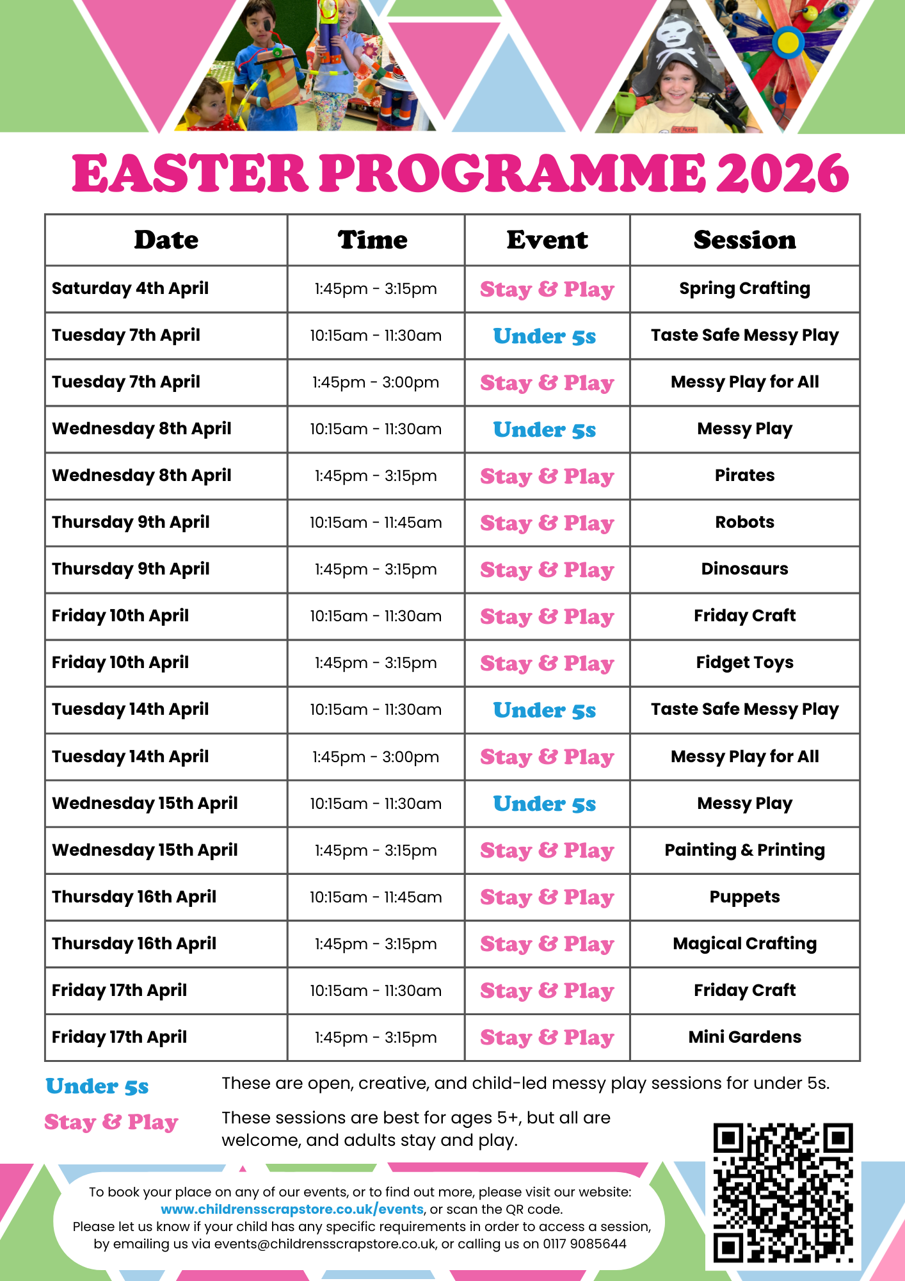

Children’s Scrapstore – Easter Programme

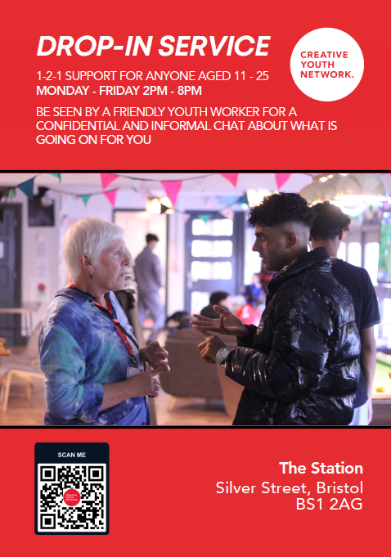

Creative Youth Network
Talk To Someone - Creative Youth Network
Talk To Someone - Creative Youth Network

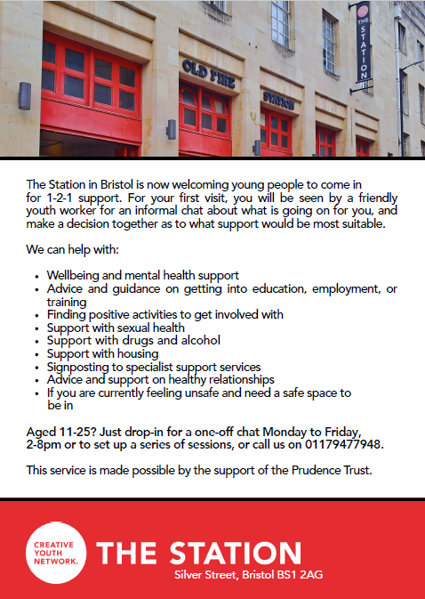

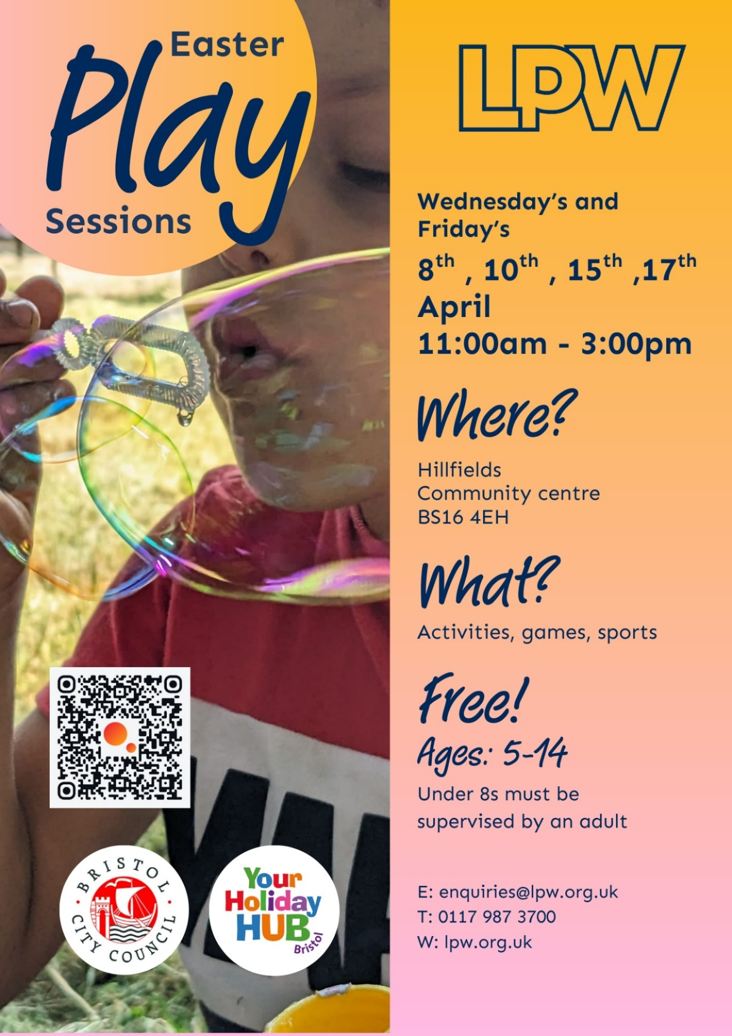

Learning Partnership West (LPW) – Easter Play Sessions

Hillfields Community Centre

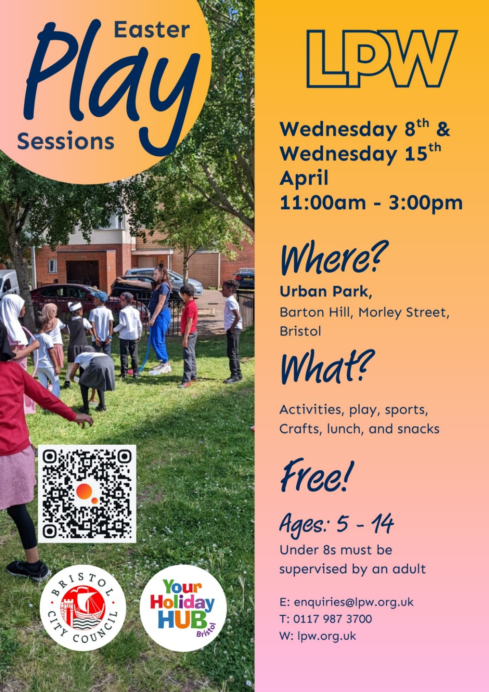

Urban Park

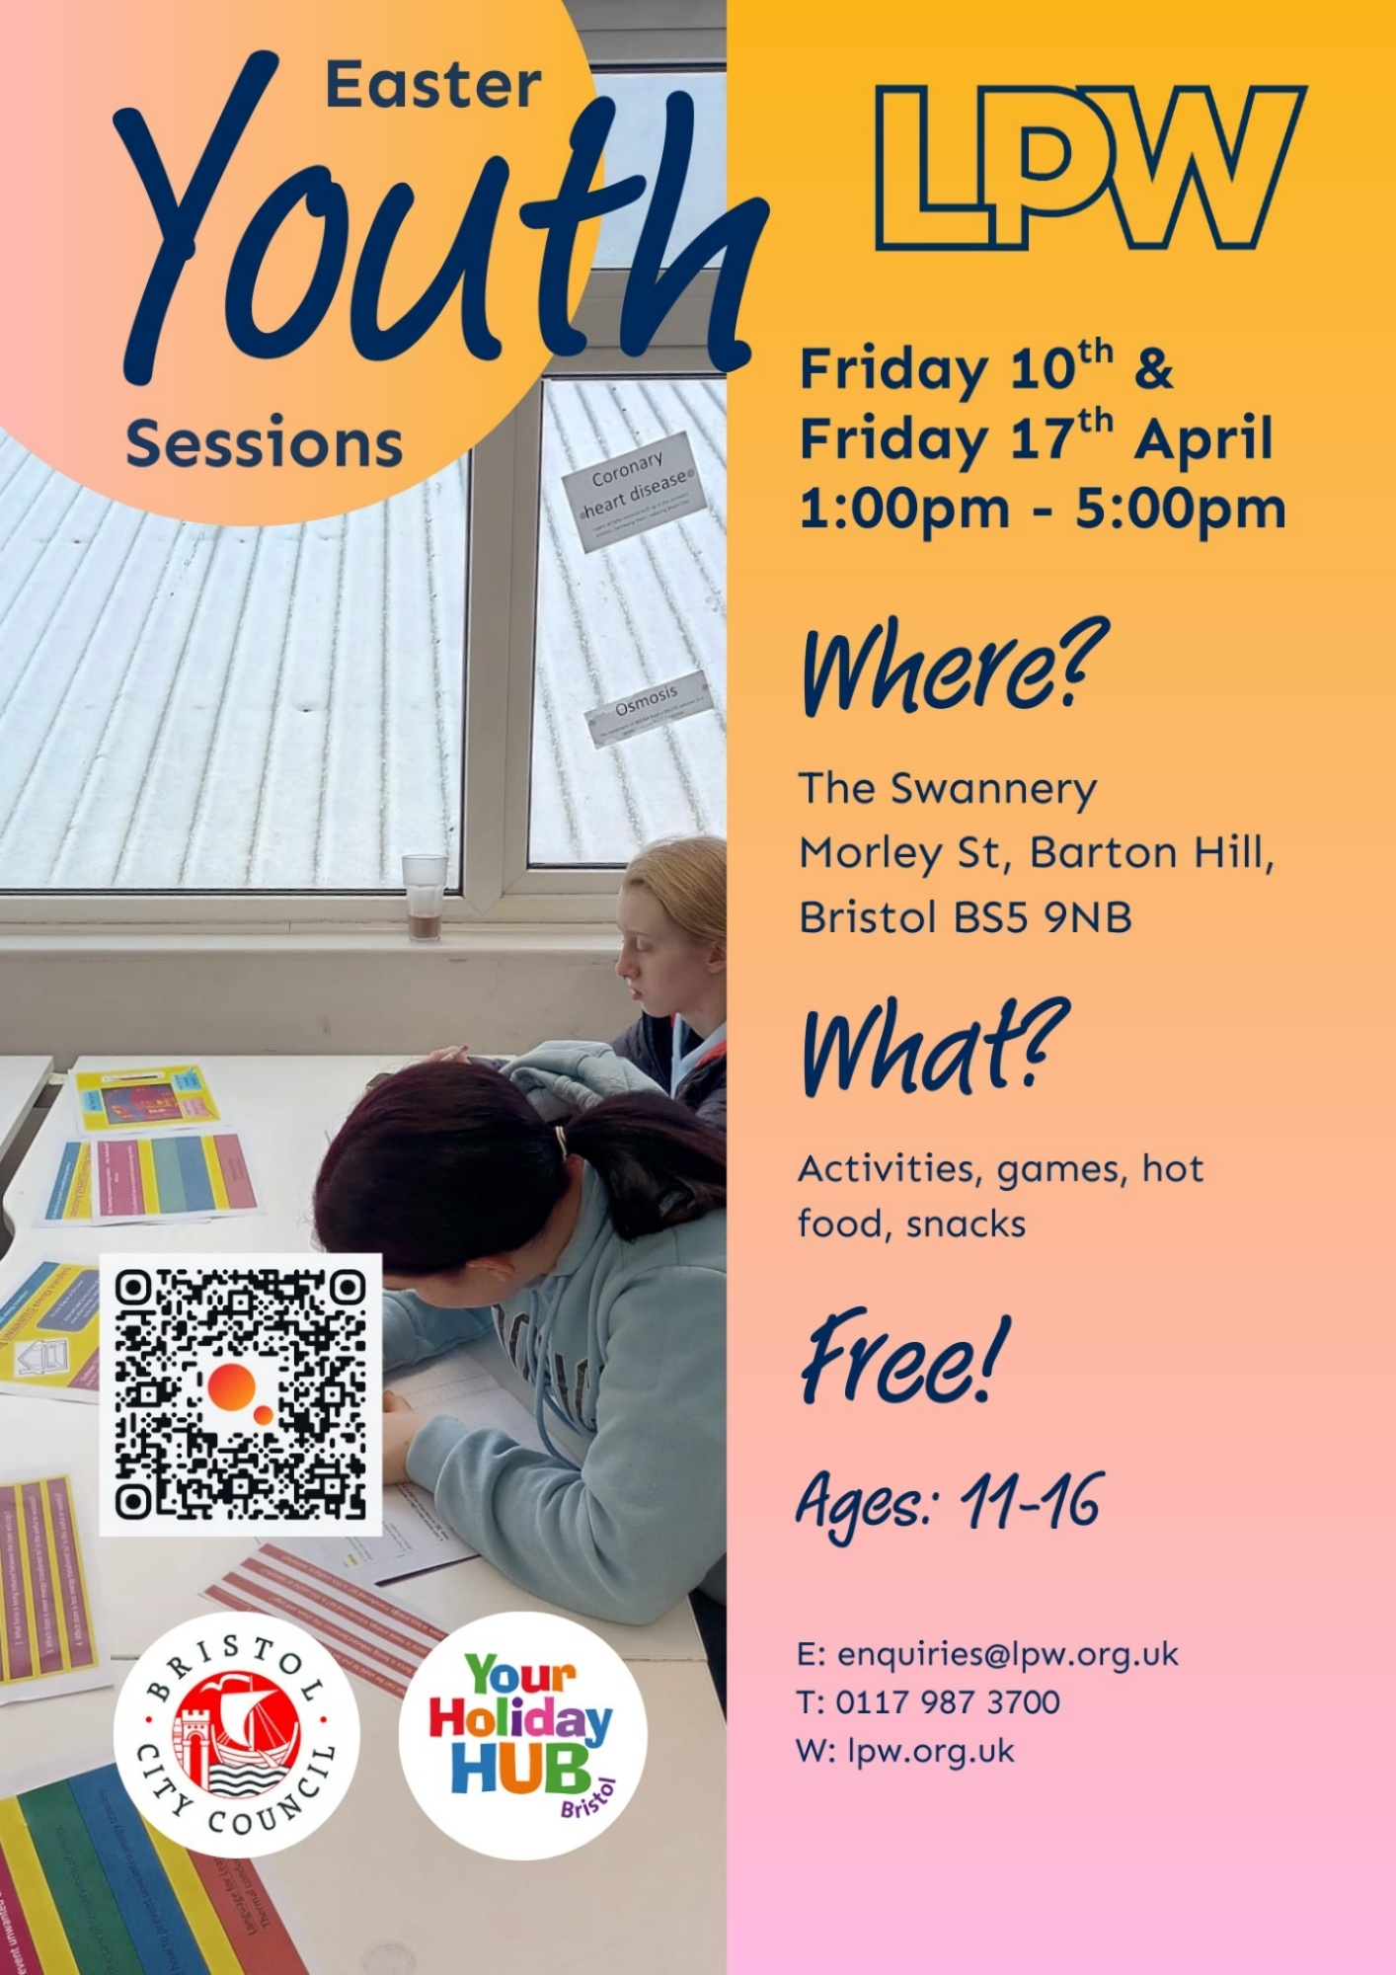

Youth Sessions (11-16) - The Swannery

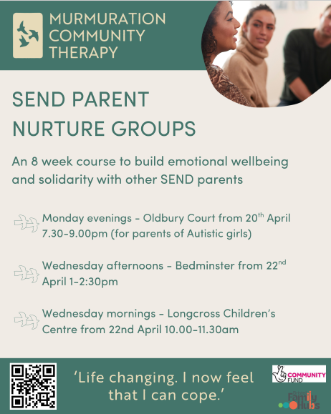

Murmuration Community Therapy

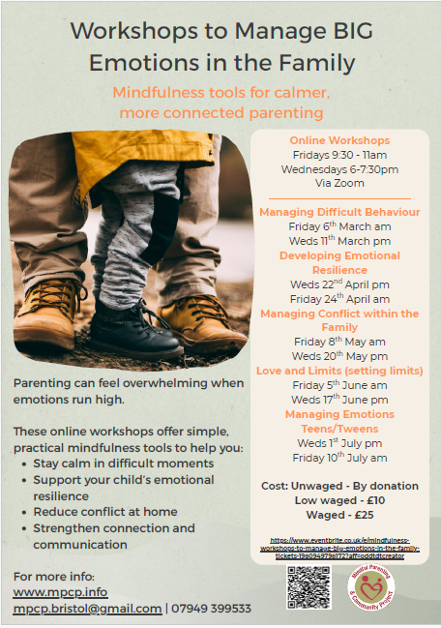

Mindful Parenting & Community Project

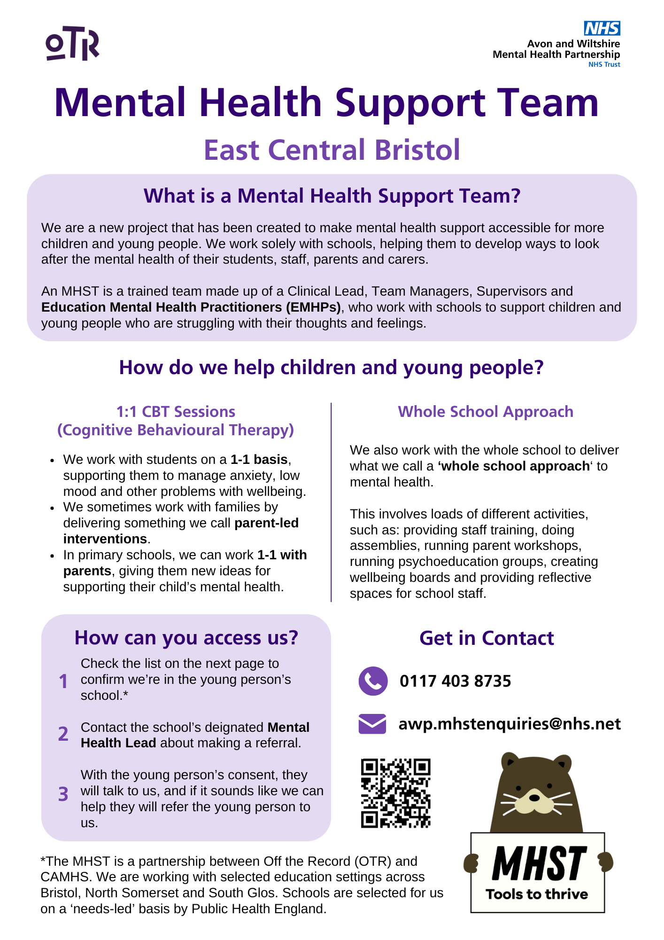

NHS – Mental Health Support Team

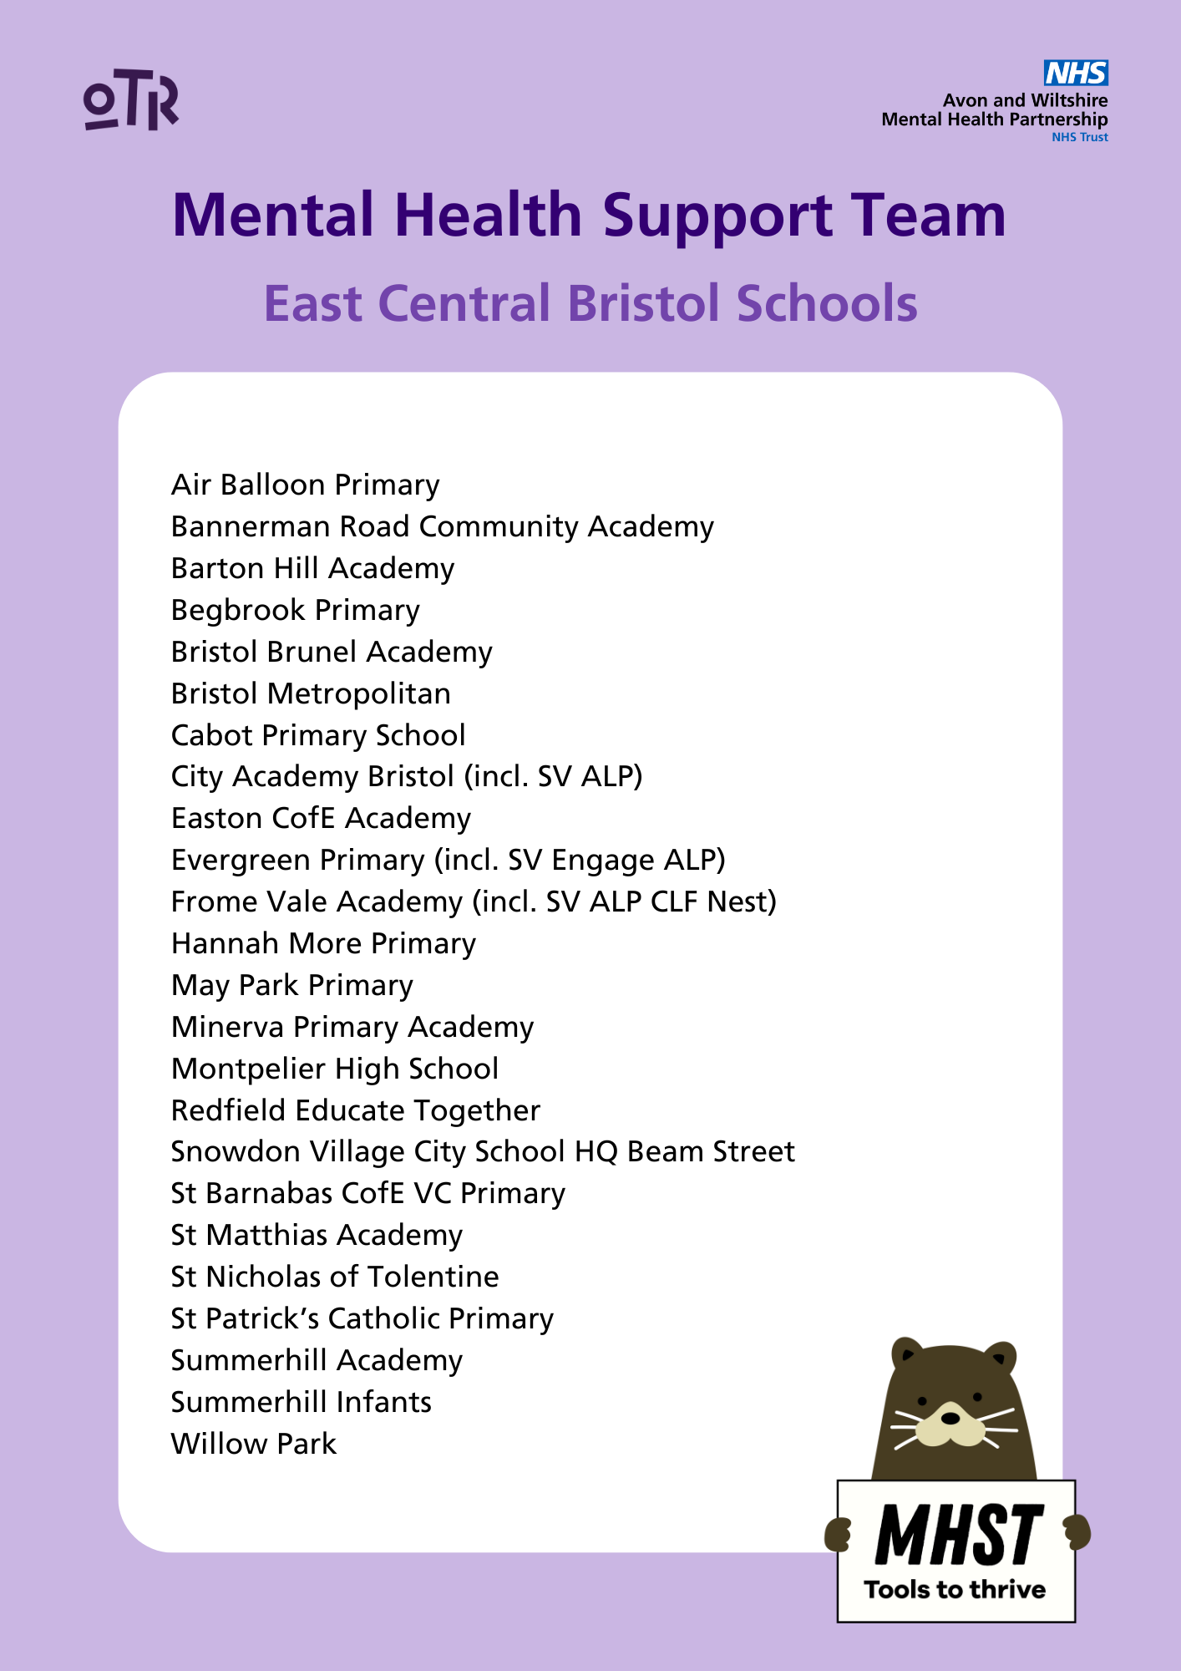

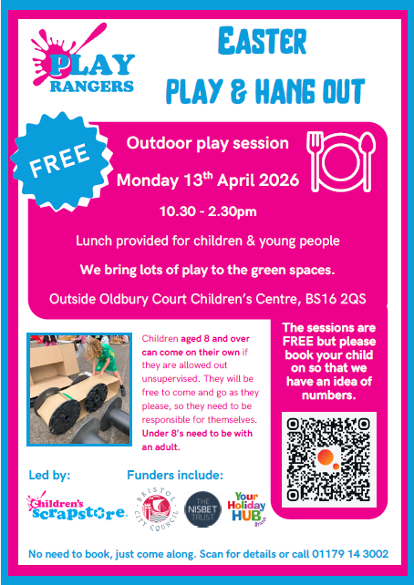

Play Rangers – Children’s Scrapstore



Premier Holidays Club

Public Health Nursing – NHS

Have your say on the future of Public Health Nursing services in Bristol

A consultation on the future of Bristol's Public Health Nursing Service is now open for everyone to share their views, especially young people, parent/ carers, and professionals working with children and young people. Please do share on.

The Public Health Nursing Service includes Health Visiting and School Nursing, and is currently commissioned by the Bristol, North Somerset and South Gloucestershire Integrated Care Board, with Bristol as an associate commissioner.

From 2028, Bristol will look to directly commission Health Visiting and School Nursing so it can be better tailored to the needs of local families’ and develop stronger links with other children’s services in the city.

Share your feedback on the plans by completing the online survey at Bristol.gov.uk/PHNursing2026 by Wednesday 29 April 2026 or email consultation@bristol.gov.uk to request the survey in a different format. The full Commissioning Strategy is also available via this link.

Key dates
- Start date: 4 March 2026
- End date: 29 April 2026


Bristol City Council
bristol.gov.uk

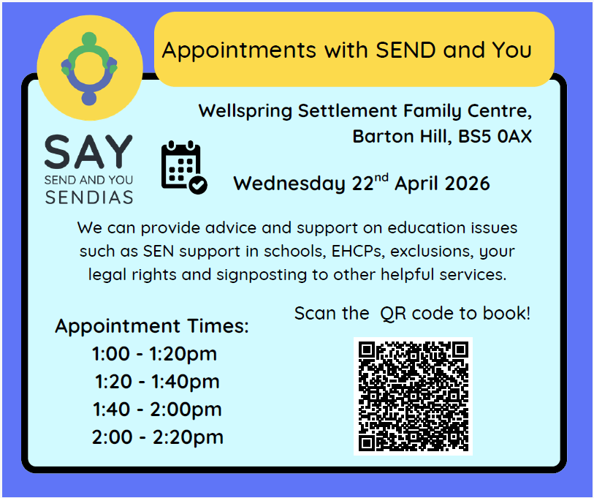
SAY – SEND and You

Appointments for Advice

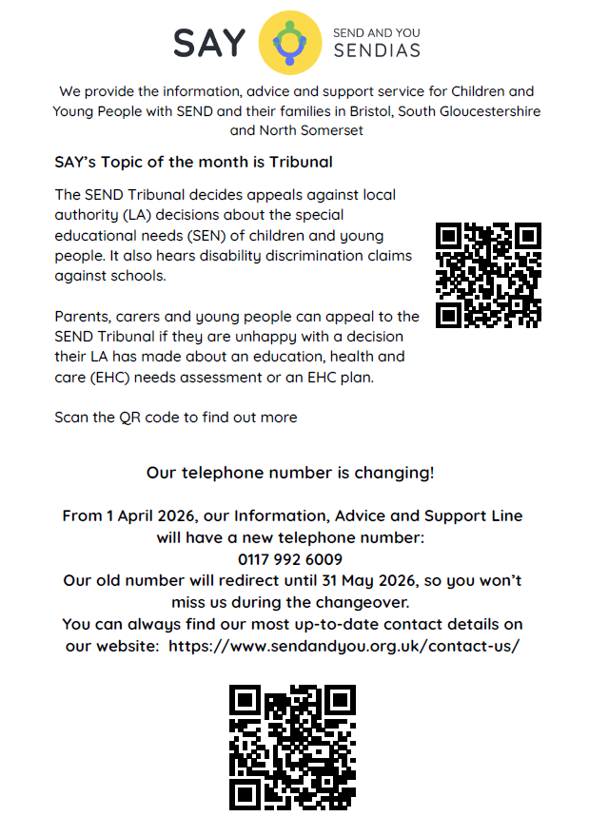
SAY’s Topic of the Month is Tribunal

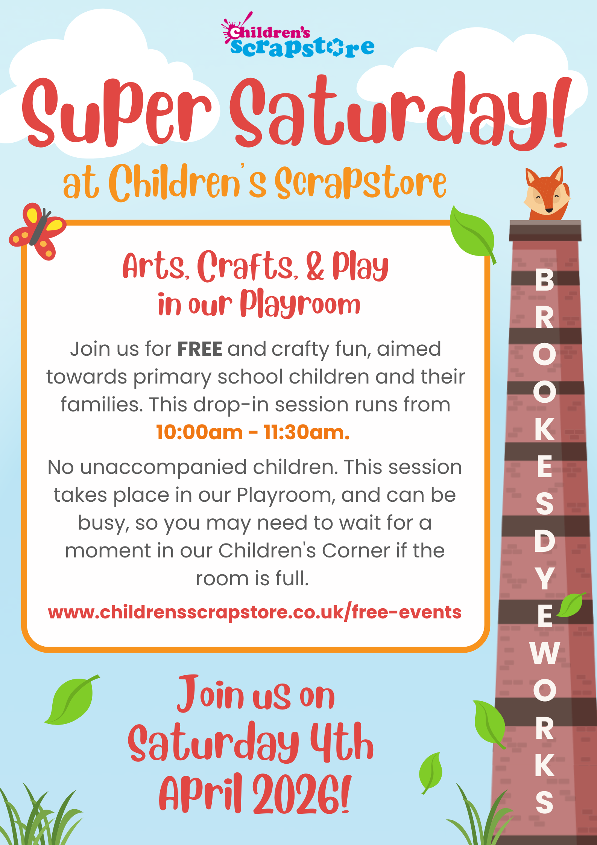
Super Saturday at Children’s Scrapstore

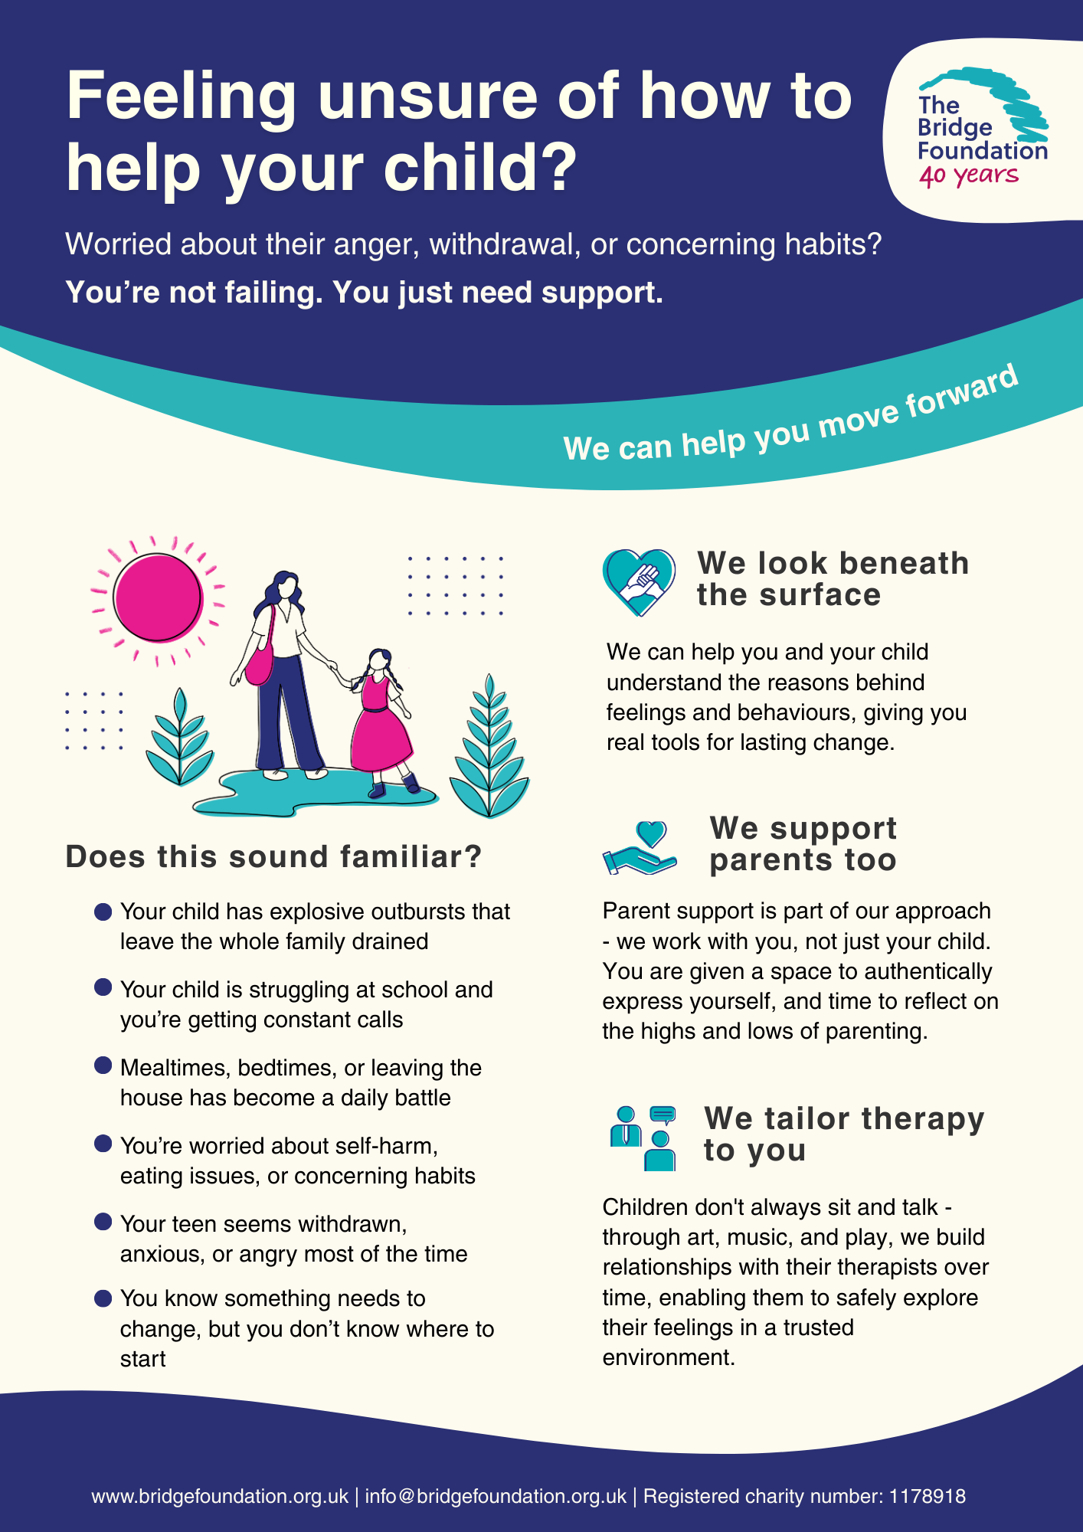
The Bridge Foundation

Therapy Support for Children and Young People

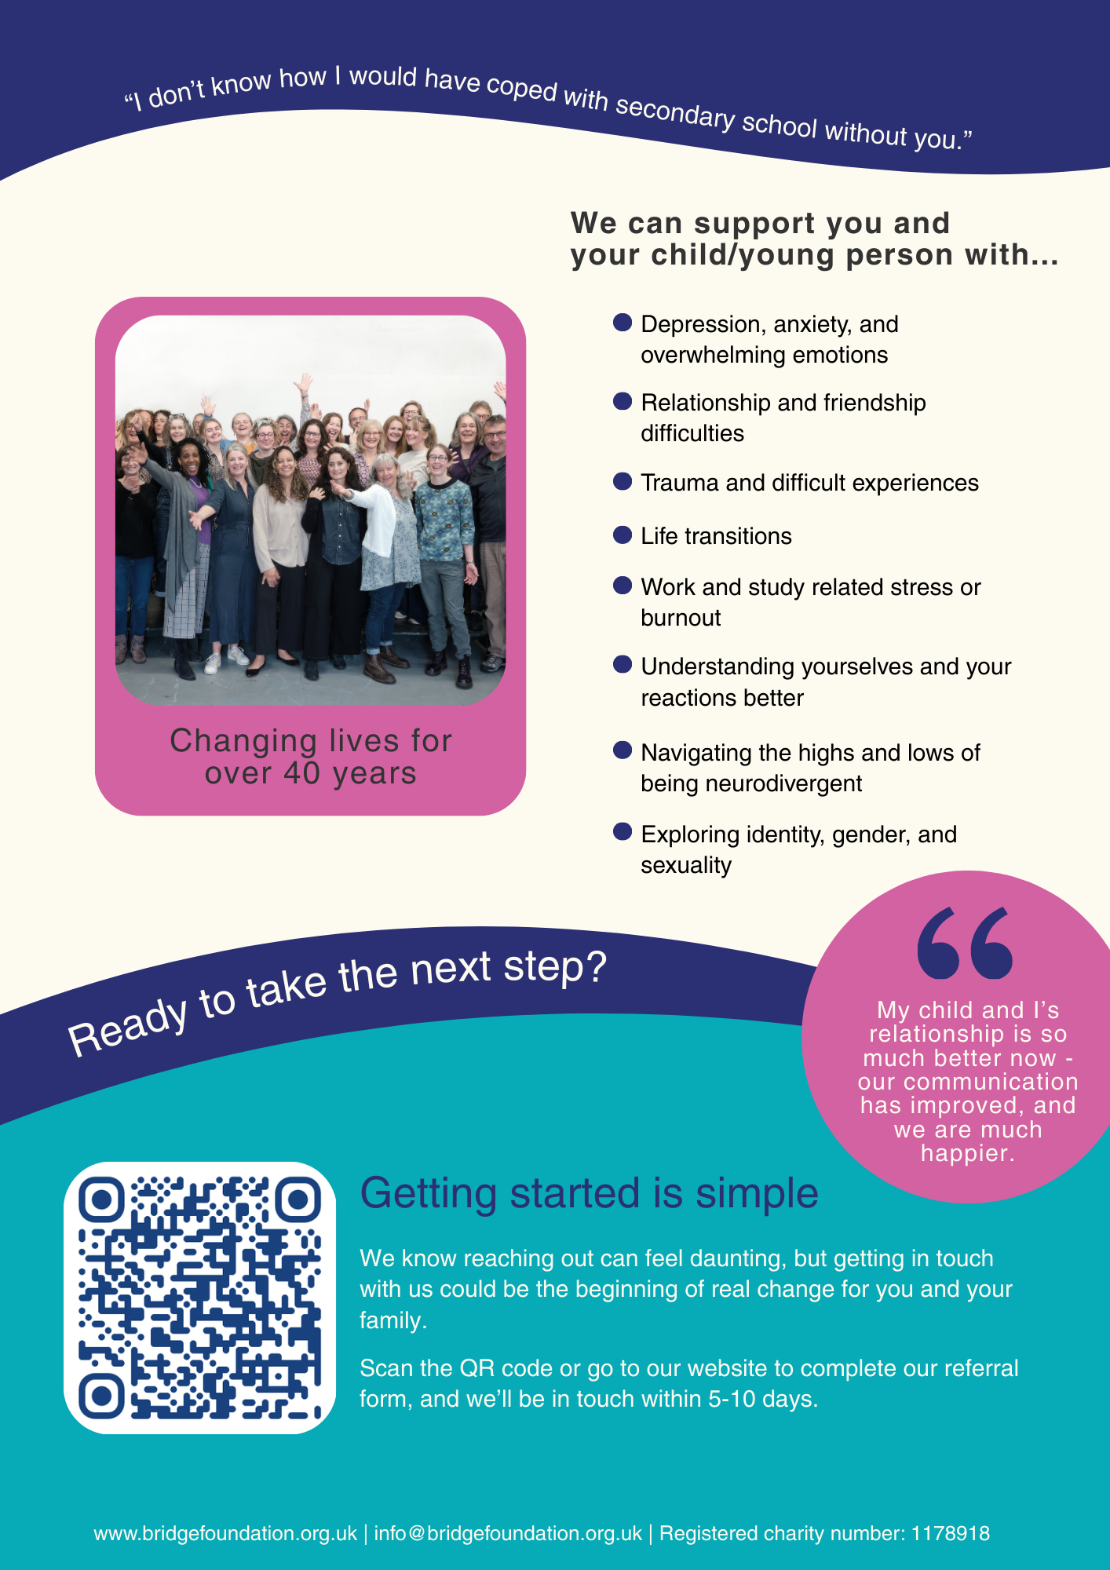

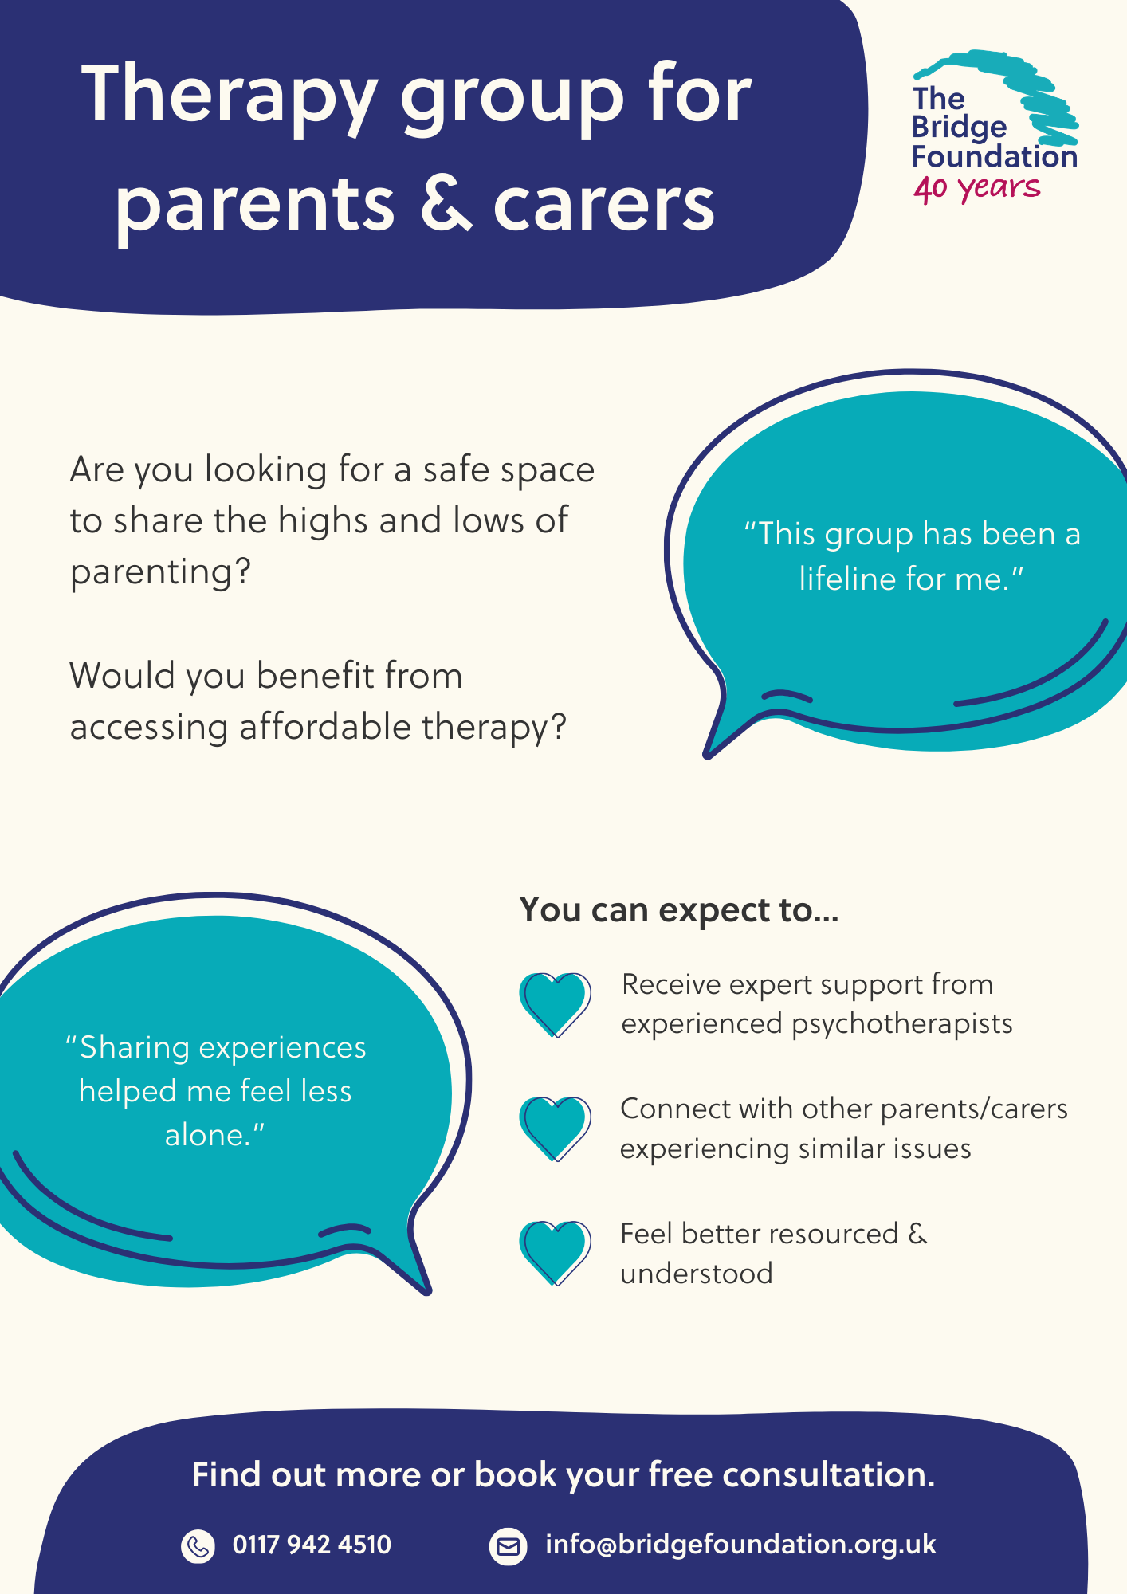
Therapy Group for Parents and Carers

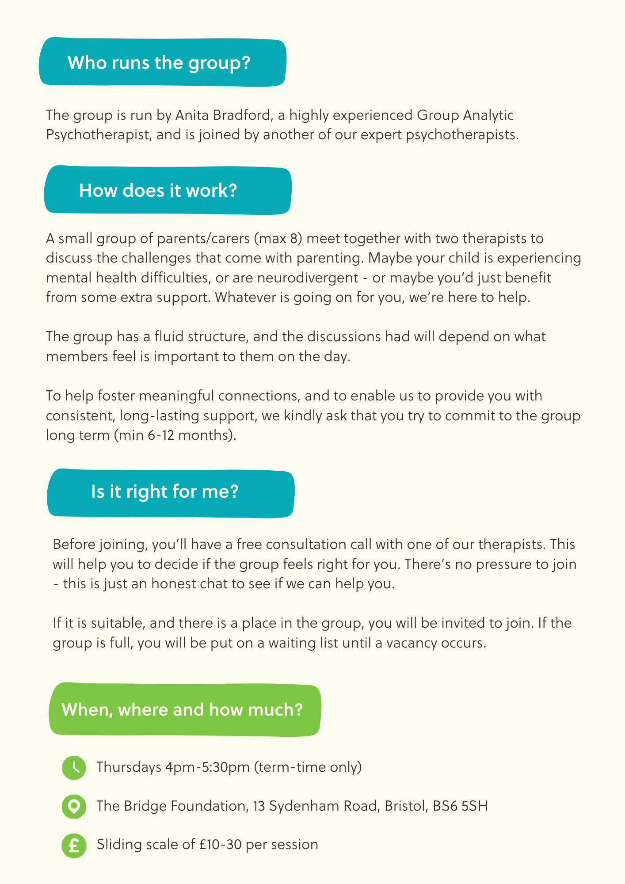

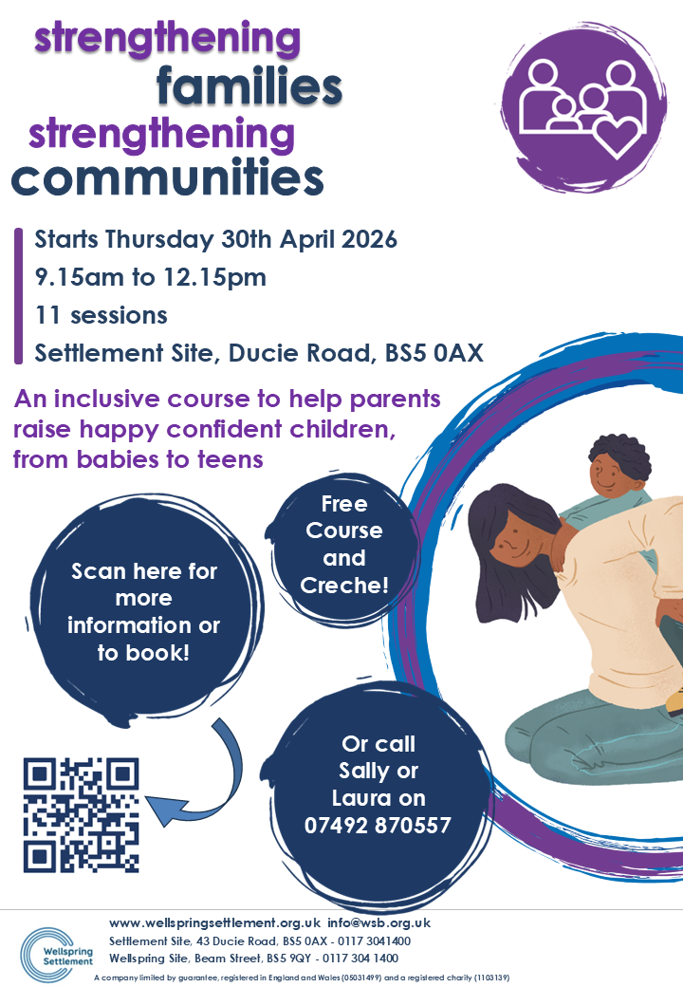
Wellspring Settlement

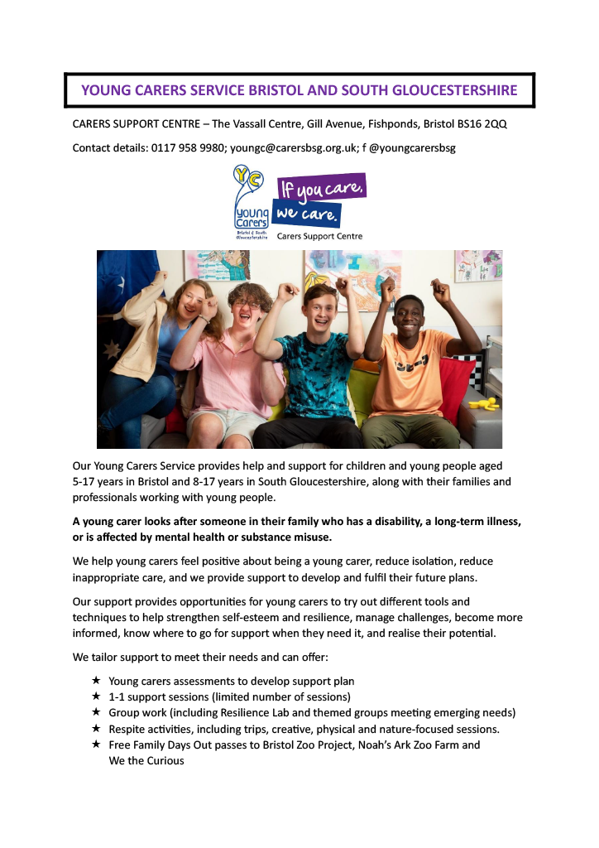
Young Carers



