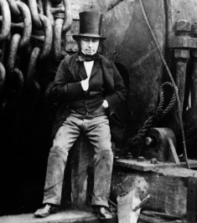
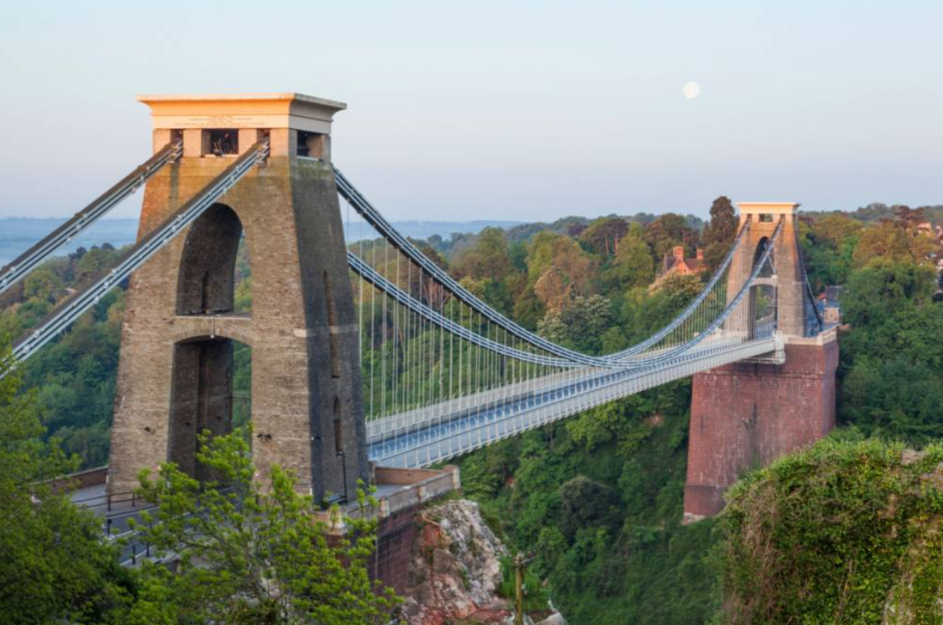
Being a philosopher
Term 4 – ‘Healthy me’. The children will learn about healthy foods, making healthy food and snack choices and why these are important for our bodies. They will learn about medicines, how they work and how to stay safe around medicine. They will learn about how to support and look after a healthy mind.

Being an author
In Term 4, our fiction focus will be Little Red Riding Hood. We will immerse ourselves in the story by stepping into the characters’ shoes, exploring new vocabulary, and practising key grammatical skills. To finish, we will innovate the tale by introducing fresh characters and creating new twists in the storyline.
For our non-fiction writing unit, we will write diary entries as Brunel. Writing in the first person, using the past tense (-ed suffix) and using time words (then, later etc.) We will read them in character to the Year 1 classes.

Year 2 - Term 4 overview
What did Brunel do for
Great Britain?

Being a reader
The children read daily as part of our shared reading sessions. Each week, we rotate between fiction, non-fiction, and poetry texts. Together, we choral read to develop fluency, discuss the books by asking and answering questions, and explore new vocabulary. At the end of the week, the book is sent home for the children to share with their families.
6th March we will celebrate ‘World Book Day’ with the theme of traditional tales.

Being a mathematician
In term 4 we will focus on the unit - Shape and Space. We will look at 2D and 3D shape names, their properties and lines of symmetry. We will look at regular and irregular shapes and how to identify them using key properties.
We will then move on to look at fractions of a shape then fractions of a number, introducing new vocabulary – half, quarter, thirds as well as visual representations and revisiting models to show the devised equal parts.

Being an engineer
The children will look at different bridges, then design and make a purposeful, functional, appealing bridge using a range of tools and materials. Evaluating their product at different stages with the aim of improving its stability and strength.
Being an historian
The children will discuss some significant people from the past, focusing on Brunel and thinking about his contributions to the wider society. They will know where people and events fit on a timeline, identify similarities and difference between ways of life now and in the past, ask and answer questions and use different sources to find information. Children will create a poster exhibiting Brunel’s life and achievements.
Being a musician
The children will learn about -The carnival of the animals by Camille Saint-Saens. Exploring ways that the composer has used instruments, rhyme, tempo and pitch to create pictures of animals in our imagination.
They will also use instruments to create music inspired by birds and birdsong, inspired by - The lark ascending by Ottorino Respighi.

Being an athlete
During our Monday PE session this term, the children will develop and apply their ball skills and counter balance with a partner through focused skill development sessions, cooperative and competitive games.
We will continue sessions with coach Alex, applying our ball skills to game situations.

