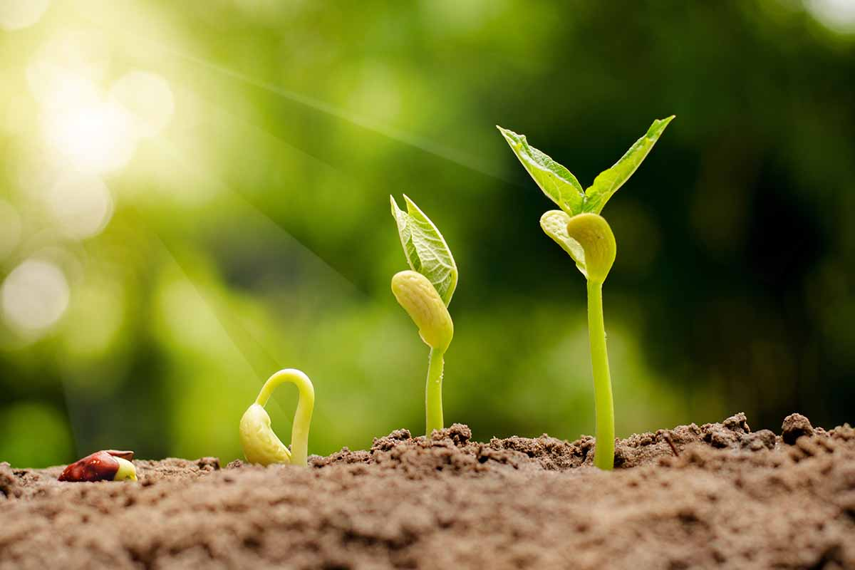
Being a Scientist
The children will observe and describe how seeds and bulbs grow into mature plants. They will investigate and describe how plants need water, light and a suitable temperature to grow and stay healthy by carrying out a series of simple tests. They will be working scientifically, using their observations and ideas to suggest answer questions. They will record findings and look for patterns.
Being a geographer
The children will look at plants around the world, recapping the name and location of the 7 continents and 5 oceans. They will identify seasonal and daily weather patterns in the UK and hot and cold areas of the world.
Being a philosopher
PSHE – ‘Relationships’ and ‘Changing me’. They will discuss the roles and responsibilities within a family, discuss friendship and the importance of trust. They will then reflect on changes throughout their life including stages of life, our mental and physical being.
RE – How should we care for others and the world and why does it matter? Discussions around the importance of looking after our planet and others, and what Christians and Muslims believe through stories.

Being an athlete
During our Monday PE session this term, the children will develop and apply their sending and receiving, and reaction and response through focused skill development sessions, cooperative and competitive games.
We will continue our Thursday session with coach Alex, where we will begin practising our skills for sports day.
Being a musician
Term 5 – Orawa (pronounced ‘Arva’) a piece by Polish composer, Wojciech Kilar. It describes a huge river travelling through Europe. The children will listen to the music, imagining the journey of the river, thinking about the scenery and drawing a piece of artwork to represent it. They will invent new music using vocal chants and body percussion.
Being an artist
The children will use a range of skills and media including sketching, collage, print and sculpture to show their express their ideas and findings. They will observe and explore texture, colour and pattern.
Being a reader
The children read daily as part of our shared reading sessions. We rotate between fiction, non-fiction, and poetry texts. Together, we choral read to develop fluency, make predictions, ask question and explore new vocabulary. At the end of the week, the book is sent home for shared reading at home.
This term we will be focusing on using our literal and inferential skills to support our verbal and written comprehension.
Being a mathematician
In term 5 we will focus on Money and Time. We will identify the value of each of the different coins and notes, use a combination of coins/notes to make different amounts and calculate the ‘change’ from a spent amount.
We will then learn about time. Focusing on recognising features of a clock, understanding the ‘hands’ – minute and hour and counting the time intervals.

Year 2 - Term 5 overview
How do plants grow near me?
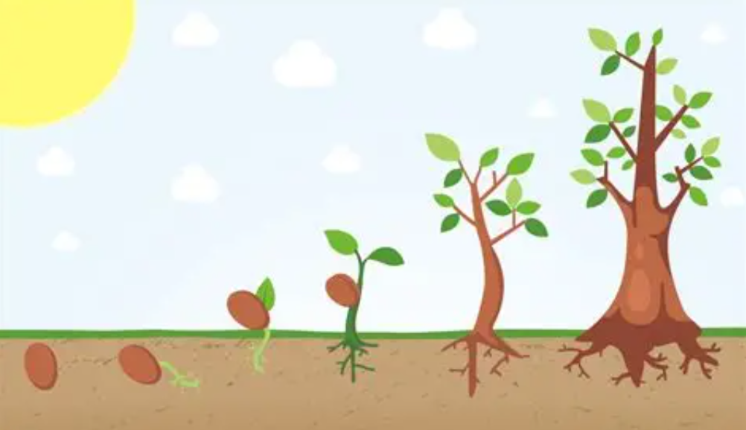
Being an author
In Term 5, our fiction text is based on the story – I follow the Fox. We will focus on applying features of the story, including new vocabulary, similes, different sentence types – question and exclamation, and noun phrases. In week 3, we will innovate the story by changing the setting and characters and applying our learned grammar.
Term 5 Non-fiction writing unit – Letters. We will look at the features of a letter, focus on writing in the first person and the structure of a letter. We will be writing letters to Year 3, sharing some interesting facts about us.

